ANAGHA ACHARYA

1BM19CS224

FLIGHT DATABASE

create database flight;

use flight;

create table flights(

flno int,

ffrom varchar(15) not null,

tto varchar(15) not null,

distance int,

departs timestamp,

arrives timestamp,

primary key(flno));

alter table flights

add price int not null;

desc flights;

create table aircraft(

aid int,

aname varchar(10),

cruisingrange int,

primary key (aid));

desc aircraft;

create table employees(

eid int,

ename varchar(15),

salary int,

primary key(eid));

desc employees;

create table certified(

eid int not null,

aid int not null,

primary key(eid,aid),

foreign key(eid) references employees(eid),

foreign key(aid) references aircraft(aid));

desc certified;

insert into flights values(101,'Bangalore','Delhi',2500,'2005-05-13 07:15:31','2005-05-13 17:15:31',5000);

insert into flights values(102,'Bangalore','Lucknow',3000,'2005-05-13 07:15:31','2005-05-13 11:15:31',6000);

insert into flights values(103,'Lucknow','Delhi',500,'2005-05-13 12:15:31','2005-05-13 17:15:31',3000);

insert into flights values(107,'Bangalore','Frankfurt',8000,'2005-05-13 07:15:31','2005-05-13 22:15:31',60000);

insert into flights values(104,'Bangalore','Frankfurt',8500,'2005-05-13 07:15:31','2005-05-13 23:15:31',75000);

insert into flights values(105,'Kolkata','Delhi',3400,'2005-05-13 07:15:31','2005-05-13 09:15:31',7000);

commit;

select \* from flights;

insert into aircraft values(101,'747',3000);

insert into aircraft values(102,'Boeing',900);

insert into aircraft values(103,'647',800);

insert into aircraft values(104,'Dreamliner',10000);

insert into aircraft values(105,'Boeing',3500);

insert into aircraft values(106,'707',1500);

insert into aircraft values(107,'Dream',120000);

commit;

select \* from aircraft;

insert into employees values(701,'A',50000);

insert into employees values(702,'B',100000);

insert into employees values(703,'C',150000);

insert into employees values(704,'D',90000);

insert into employees values(705,'E',40000);

insert into employees values(706,'F',60000);

insert into employees values(707,'G',90000);

commit;

select \* from employees;

insert into certified values(701,101);

insert into certified values(701,102);

insert into certified values(701,106);

insert into certified values(701,105);

insert into certified values(702,104);

insert into certified values(703,104);

insert into certified values(704,104);

insert into certified values(702,107);

insert into certified values(703,107);

insert into certified values(704,107);

insert into certified values(702,101);

insert into certified values(703,105);

insert into certified values(704,105);

insert into certified values(705,103);

commit;

select \* from certified;

#Query1

select distinct a.aname

from aircraft a

where a.aid in( select c.aid

from certified c, employees e

where c.eid=e.eid and

not exists(select \* from employees e1 where e1.eid=e.eid and e1.salary<80000));

#Query2

select c.eid,max(a.cruisingrange)

from certified c, aircraft a

where c.aid=a.aid

group by c.eid

having count(\*)>3;

#Query3

select distinct e.ename

from employees e where e.salary<(select min(f.price) from flights f where f.ffrom='Bangalore' and f.tto='Frankfurt');

#Query4

select c.aid,avg(e.salary)

from certified c,employees e

where c.aid in(select aid from aircraft where cruisingrange>1000)

and e.eid=c.eid

group by c.aid;

#Query5

select distinct e.ename

from employees e, certified c, aircraft a

where e.eid=c.eid

and c.aid=a.aid

and a.aname like 'Boeing%';

#Query6

select a.aid

from aircraft a where a.cruisingrange>(select min(f.distance) from flights f where f.ffrom='Bangalore' and f.tto='Frankfurt');

#Query7

select f.departs

from flights f

where f.flno in ( ( select f0.flno

from flights f0

where f0.ffrom = 'Bangalore' and f0.tto = 'Delhi'

and extract(hour from f0.arrives) < 18 )

union

(select f0.flno

from flights f0, flights f1

where f0.ffrom = 'Bangalore' and f0.tto <> 'Delhi'

and f0.tto = f1.ffrom and f1.tto = 'Delhi'

and f1.departs > f0.arrives

and extract(hour from f1.arrives) < 18)

union

(select f0.flno

from flights f0, flights f1, flights f2

where f0.ffrom = 'Bangalore'

and f0.tto = f1.ffrom

and f1.tto = f2.ffrom

and f2.tto = 'Delhi'

and f0.tto <> 'Delhi'

and f1.tto <> 'Delhi'

and f1.departs > f0.arrives

and f2.departs > f1.arrives

and extract(hour from f2.arrives) < 18));

FLIGHTS TABLE

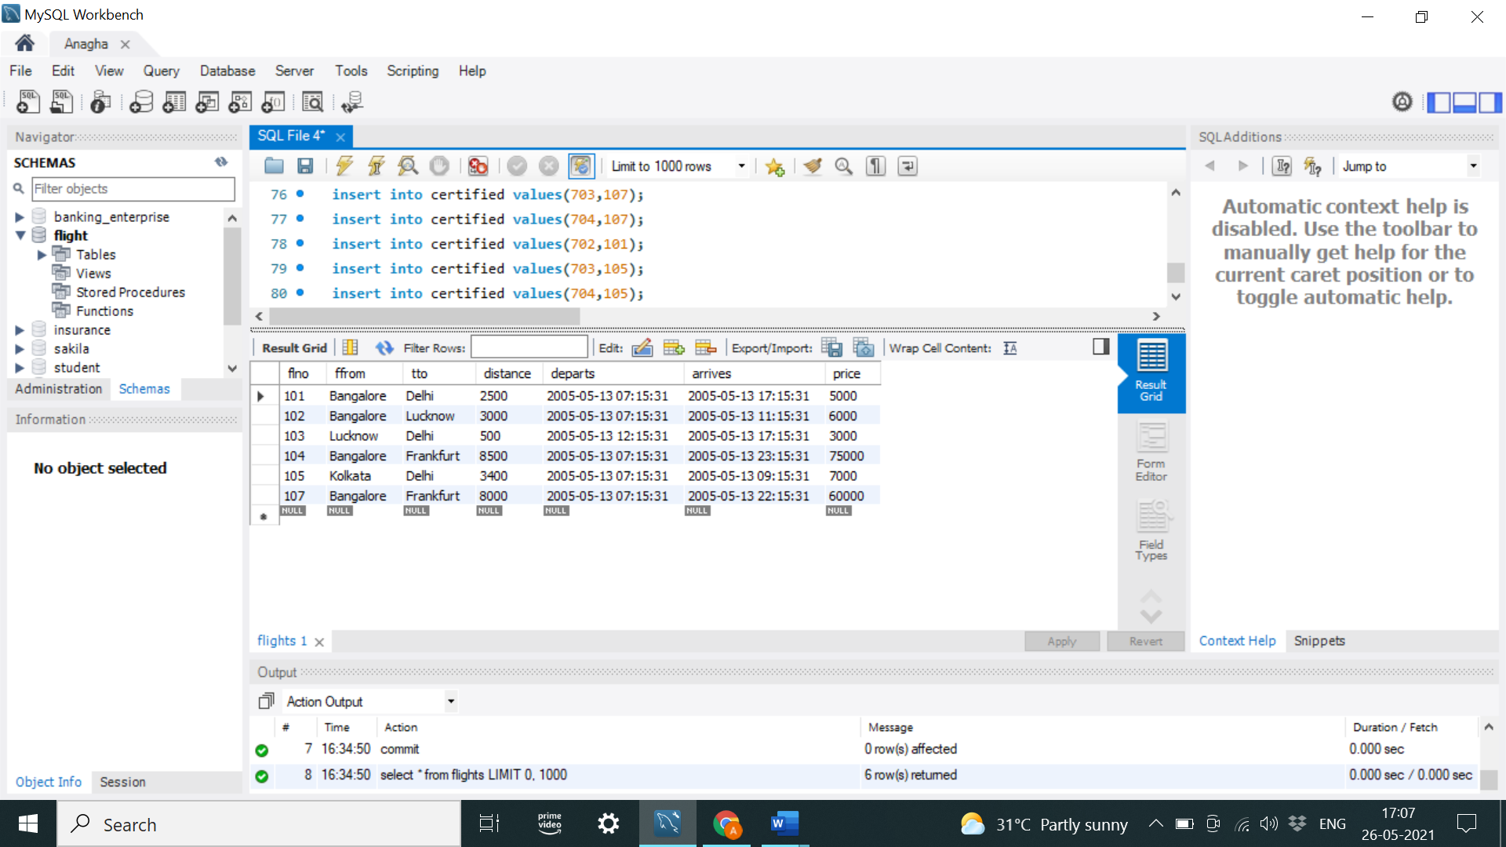

AIRCRAFT TABLE EMPLOYEES TABLE

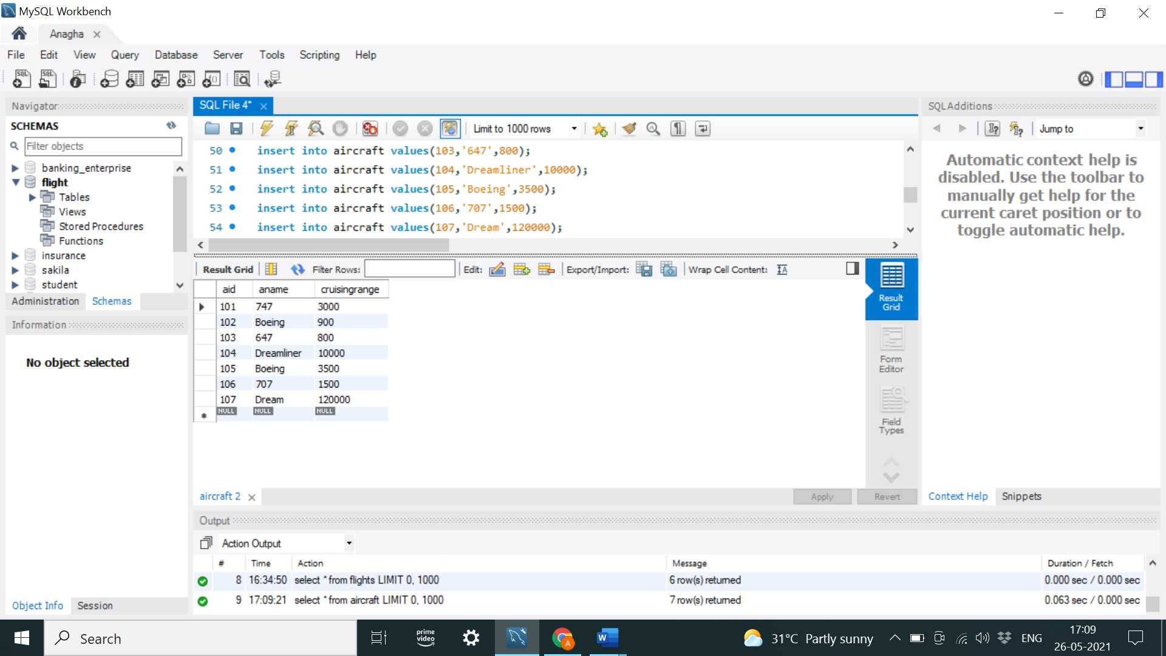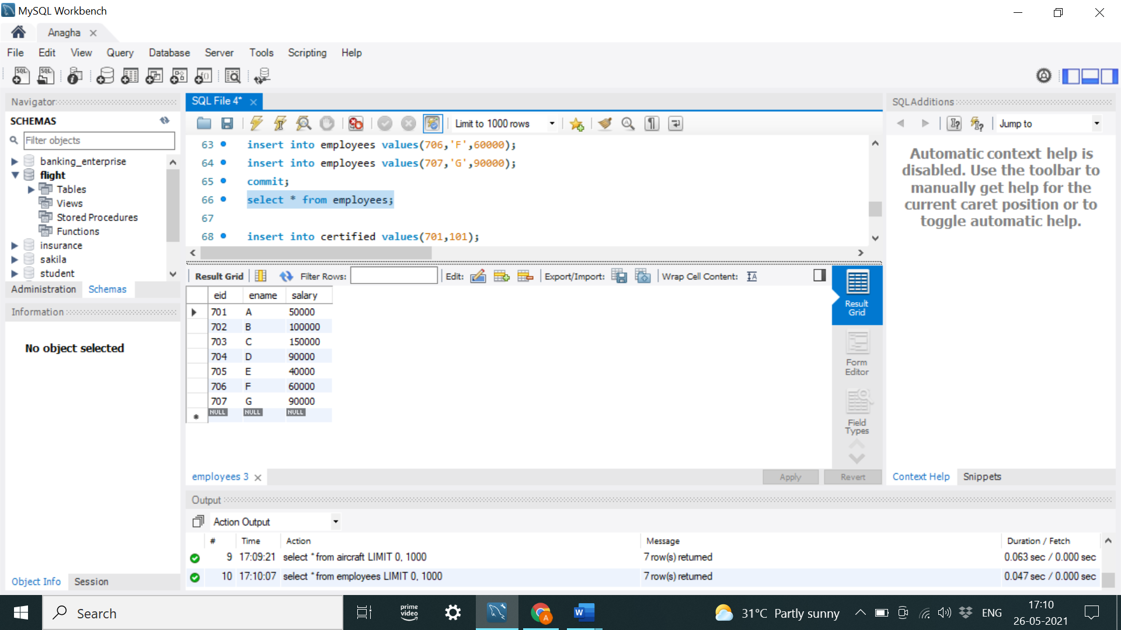

CERTIFIED TABLE

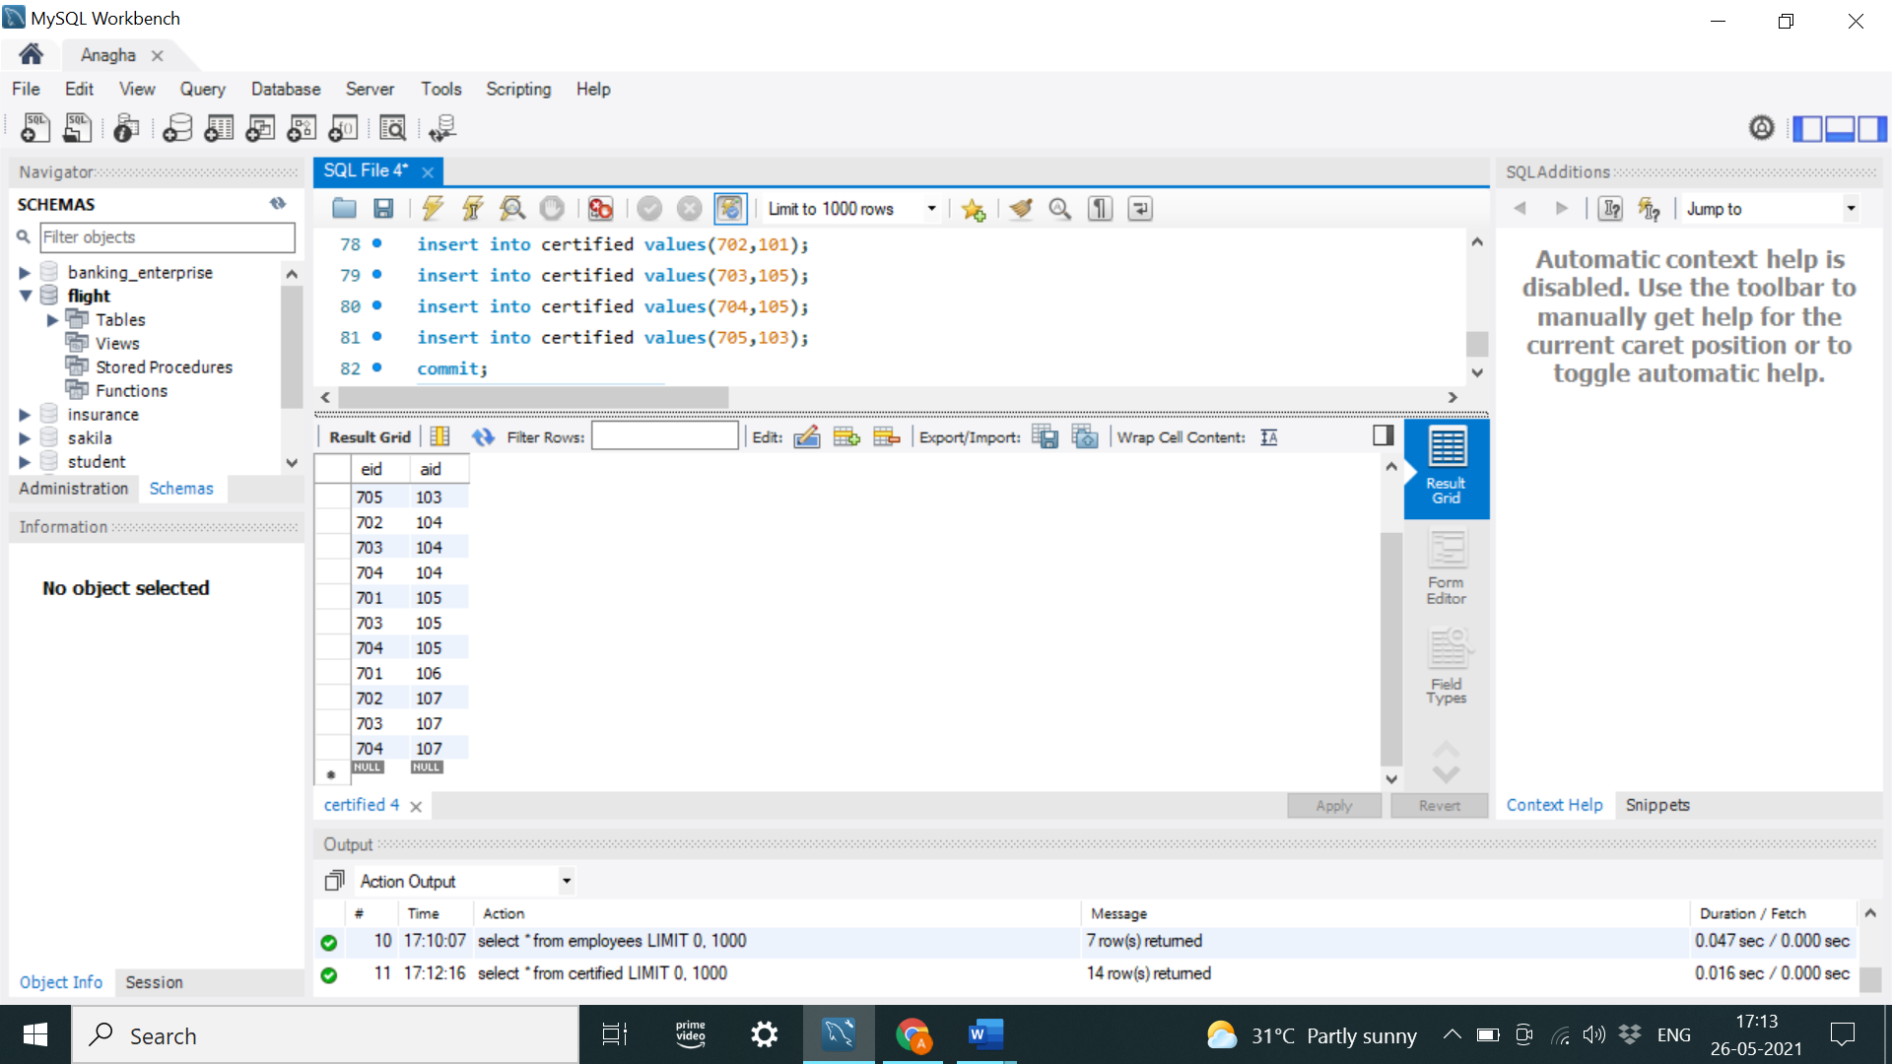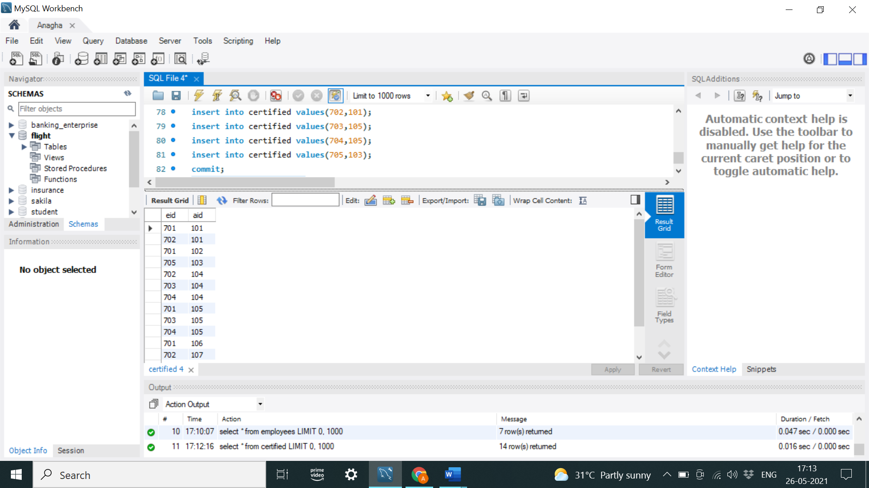

Find the names of aircraft such that all pilots certified to operate them have salaries more than Rs.80,000.

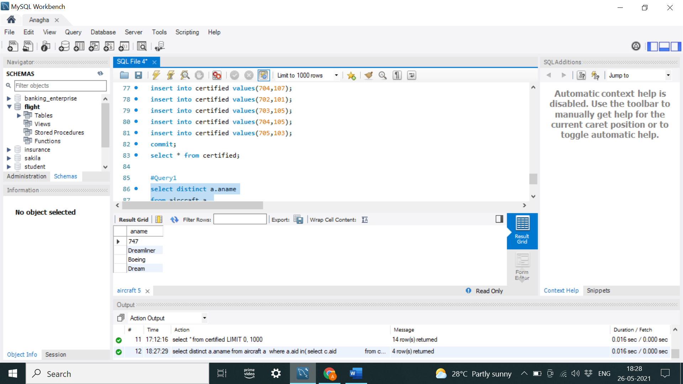

For each pilot who is certified for more than three aircrafts, find the eid and the maximum cruisingrange of the aircraft for which she or he is certified.

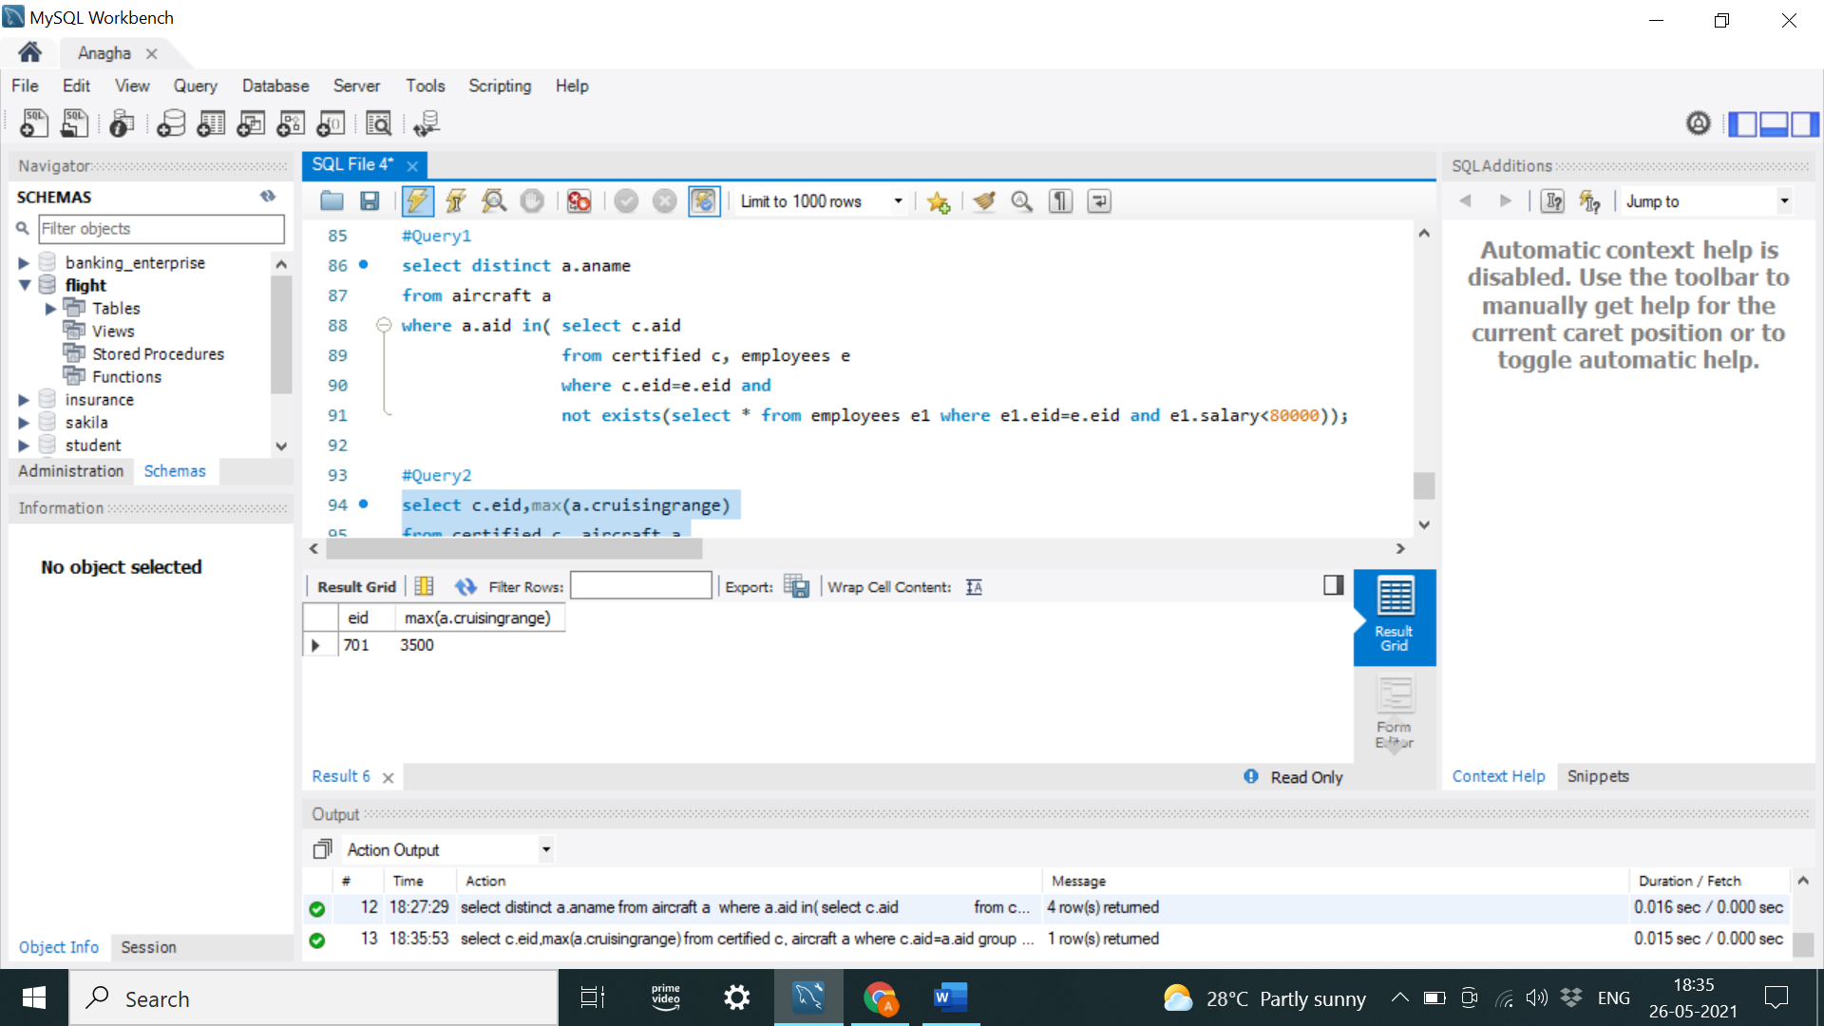

Find the names of pilots whose salary is less than the price of the cheapest route from Bengaluru to Frankfurt.

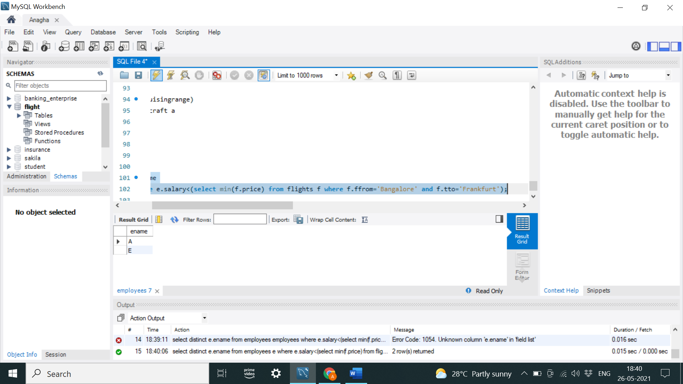

For all aircraft with cruisingrange over 1000 Kms, find the name of the aircraft and the average salary of all pilots certified for this aircraft.

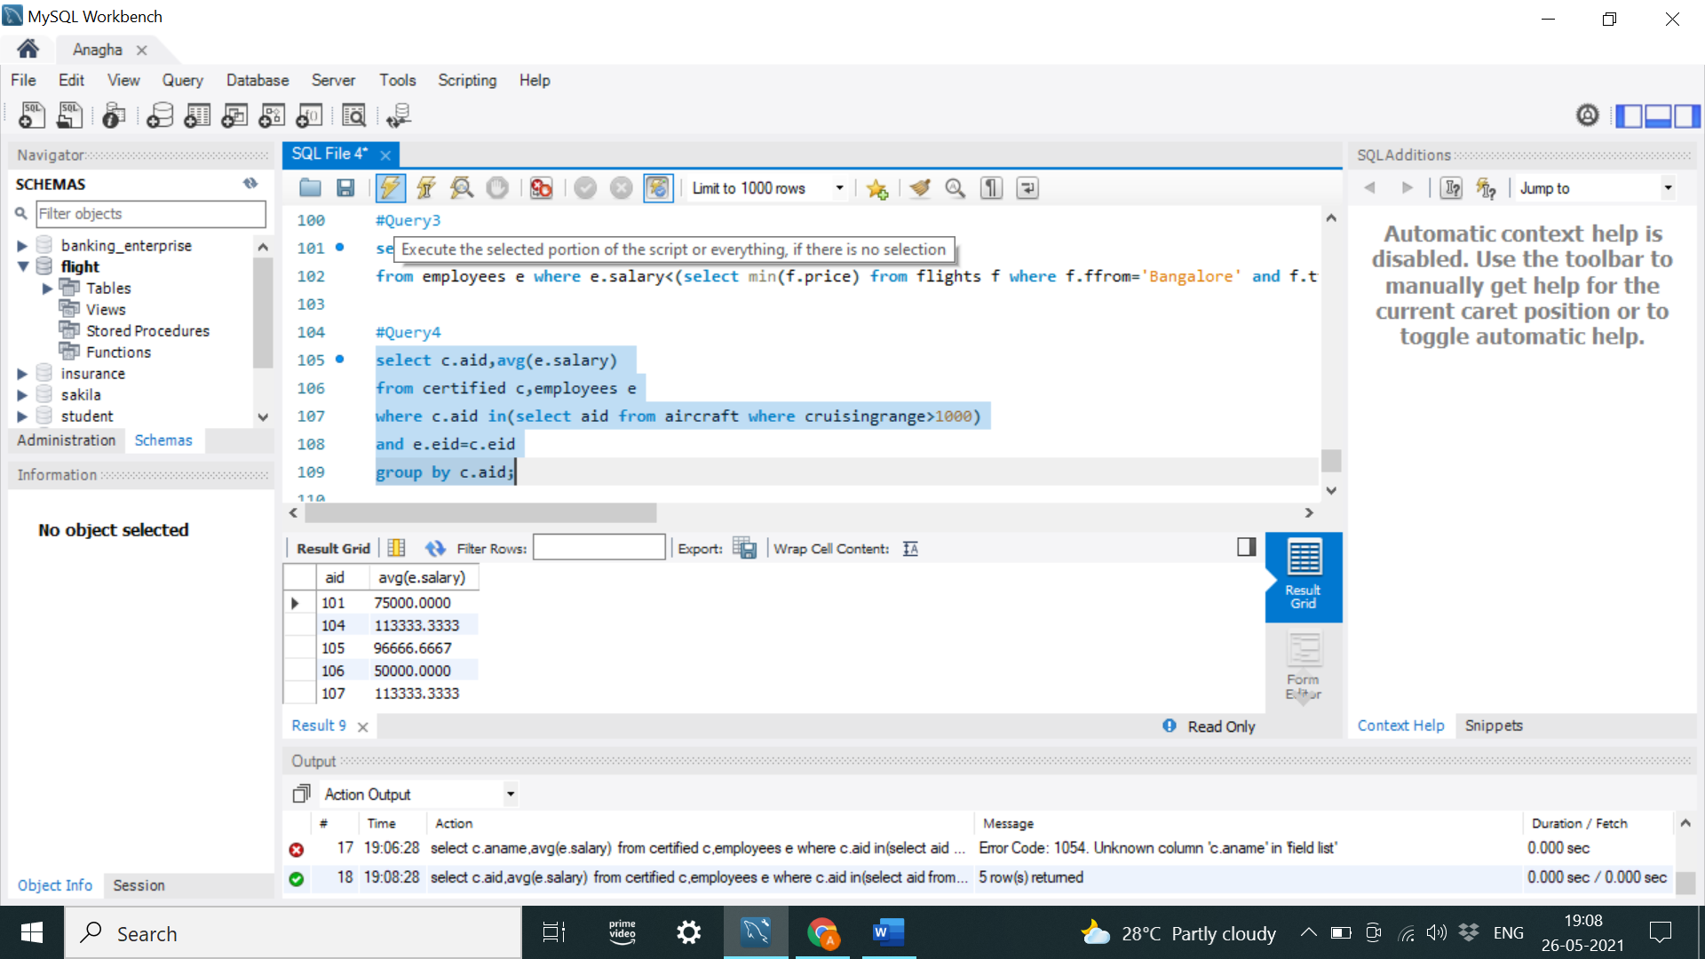

Find the names of pilots certified for some Boeing aircraft.

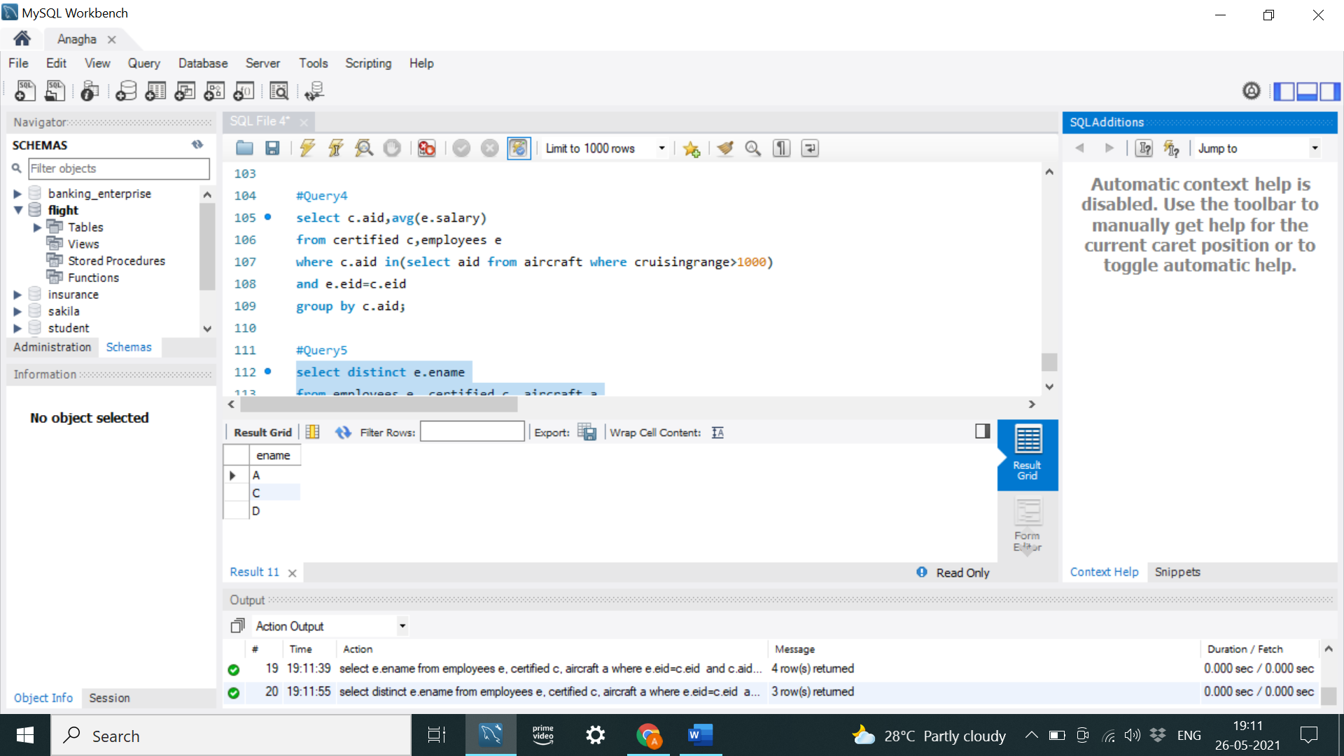

Find the aids of all aircraft that can be used on routes from Bengaluru to New Delhi

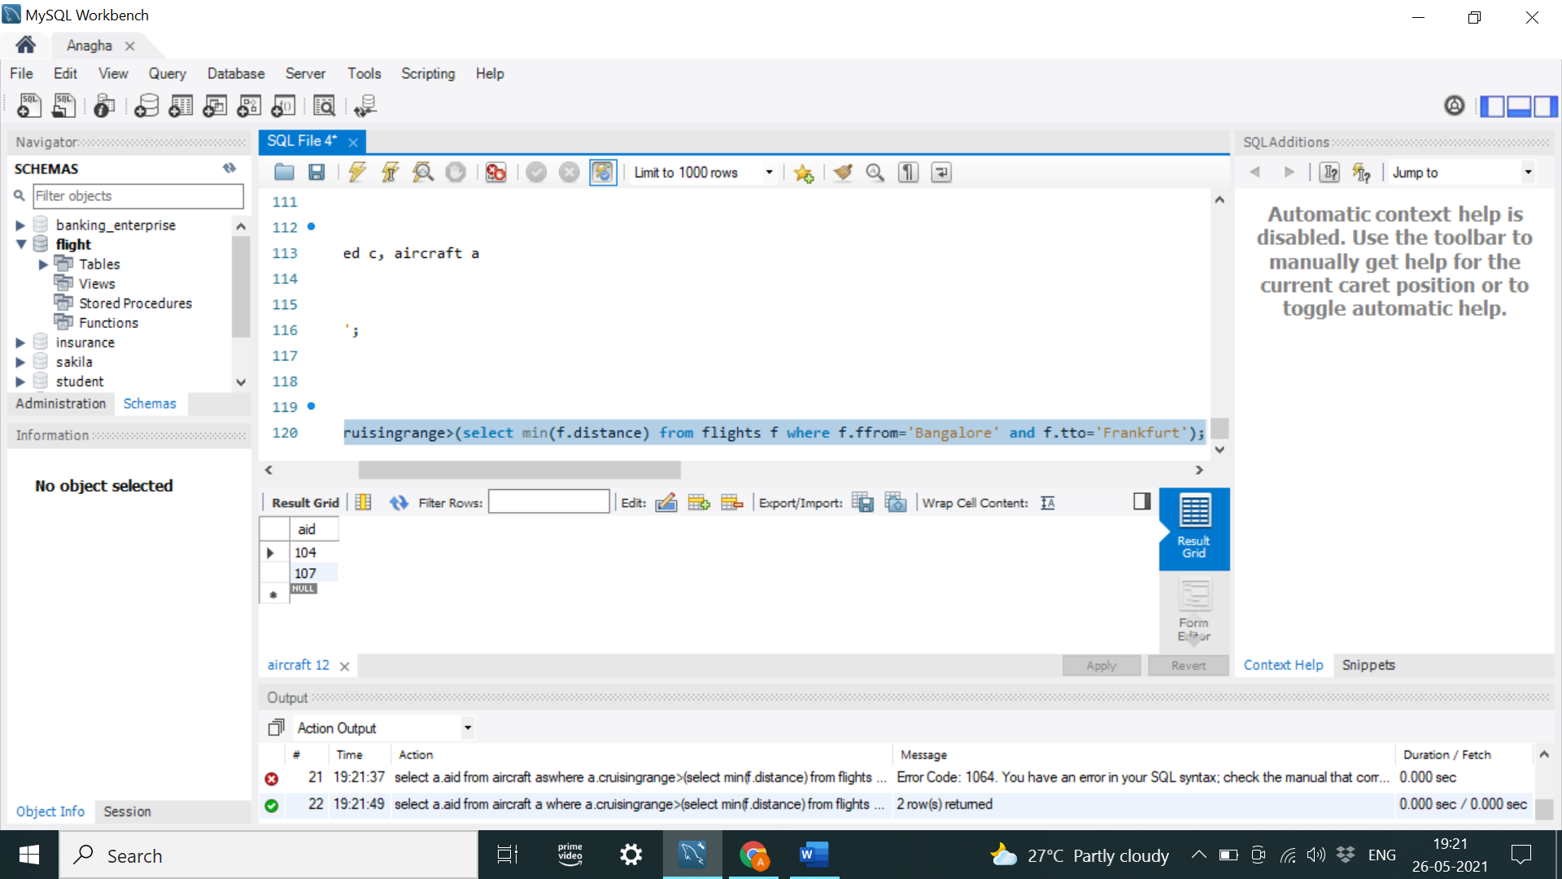

A customer wants to travel from Delhi to Bangalore with no more than two changes of flight. List the choice of departure times from Bangalore if the customer wants to arrive in Delhi by 6 p.m.

